11/5/2023

Internship Tasks

Rabia Rehman

Registration Number:

2021-BSE-026

Semester:

5th

University:

Fatima Jinnah Women University

Programming Language:

C++ (Tasks done in c++)

**LinkedIn Profile:**  [**linkedin.com/in/rabia-rehman-274018250**](https://www.linkedin.com/in/rabia-rehman-274018250)

**Email-ID:**

[**rabiarehman.0123@gmail.com**](mailto:rabiarehman.0123@gmail.com)

**Task 1**

**“Setting up the system and ordering the main items”**

**Code:**

// Task1RabiaRehman.cpp : Defines the entry point for the console application.

//

#include "stdafx.h"

#include <iostream>

#include <string>

using namespace std;

//Task1 part(a)

const string caseItems[] = {"A1", "A2"};

const string caseDescriptions[] = {"Compact", "Tower"};

const double casePrices[] = {75.00, 150.00};

const string ramItems[] = {"B1", "B2", "B3"};

const string ramDescriptions[] = {"8 GB", "16 GB", "32 GB"};

const double ramPrices[] = {79.99, 149.99, 299.99};

const string hddItems[] = {"C1", "C2", "C3"};

const string hddDescriptions[] = {"1 TB HDD", "2 TB HDD", "4 TB HDD"};

const double hddPrices[] = {49.99, 89.99, 129.99};

void displayItems(const string items[], const string descriptions[], const double prices[], int size)

{

for (int i = 0; i < size; i++)

{

cout << items[i] << " - " << descriptions[i] << " ($" << prices[i] << ")" << endl;

}

}

int _tmain(int argc, _TCHAR* argv[])

{

cout<<"***************************************************************"<<endl;

cout<<"* ___________________________________ *"<<endl;

cout<<"* |Welcome to the Online Computer Shop| *"<<endl;

cout<<"* ----------------------------------- *"<<endl;

cout<<"***************************************************************"<<endl;

string EnterCase, EnterRam, EnterHDD;

double totalPrice = 200.00;

// Task1 part(b) choose one

while (true)

{

cout<<" |CASE SELECTION| "<<endl;

cout << "Select one case from the following options:" << endl;

displayItems(caseItems, caseDescriptions, casePrices, 2);

cout << "Enter the item code of your choice: ";

cin >> EnterCase;

bool validCase = false;

for (int i = 0; i < 2; i++) {

if (EnterCase == caseItems[i]) {

validCase = true;

totalPrice += casePrices[i];

break;

}

}

if (validCase)

{

break;

}

cout << "Invalid case selection. Please try again." << endl;

system("pause");

}

while (true)

{

cout<<" |RAM SELECTION| "<<endl;

cout << "Select one RAM from the following options:" << endl;

displayItems(ramItems, ramDescriptions, ramPrices, 3);

cout << "Enter the item code of your choice: ";

cin >> EnterRam;

bool validRam = false;

for (int i = 0; i < 3; i++) {

if (EnterRam == ramItems[i]) {

validRam = true;

totalPrice += ramPrices[i];

break;

}

}

if (validRam) {

break;

}

cout << "Invalid RAM selection. Please try again." << endl;

system("pause");

}

while(true)

{

cout<<" |HDD SELECTION| "<<endl;

cout << "Select one Main Hard Disk Drive from the following options:" << endl;

displayItems(hddItems, hddDescriptions, hddPrices, 3);

cout << "Enter the item code of your choice: ";

cin >> EnterHDD;

bool validHDD = false;

for (int i = 0; i < 3; i++) {

if (EnterHDD == hddItems[i]) {

validHDD = true;

totalPrice += hddPrices[i];

break;

}

}

if (validHDD)

{

break;

}

cout << "Invalid Main Hard Disk Drive selection. Please try again." << endl;

system("pause");

}

//Task1 part(d) Output the chosen items and the total price

cout<<" |CHOOSEN ITEMS| "<<endl;

cout << "You have chosen the following items:" << endl;

cout << "Case: " << EnterCase << " - " << caseDescriptions[EnterCase == "A1" ? 0 : 1] << endl;

cout << "RAM: " << EnterRam << " - " << ramDescriptions[EnterRam == "B1" ? 0 : (EnterRam == "B2" ? 1 : 2)] << endl;

cout << "Main Hard Disk Drive: " <<EnterHDD << " - " << hddDescriptions[EnterHDD == "C1" ? 0 : (EnterHDD == "C2" ? 1 : 2)] << endl;

cout<<" |TOTAL PRICE| "<<endl;

cout << "Total Price: $" << totalPrice << endl;

system("pause");

return 0;

}

**Output:**

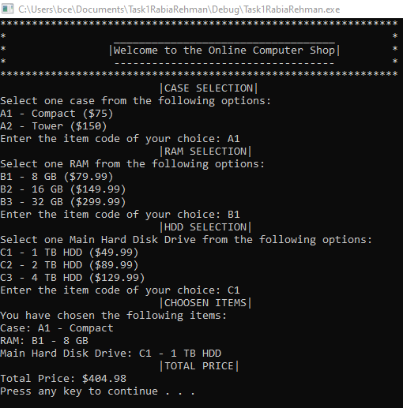

**Error message by entering the wrong:**

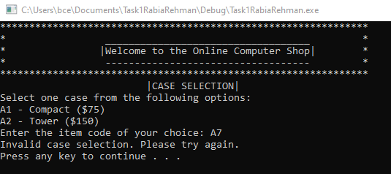

**After clicking on the Enter button this will appear:**

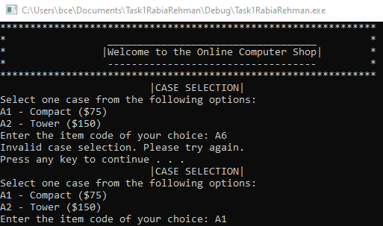

**Task 2**

**“Ordering additional items”**

**Code:**

#include "stdafx.h"

#include <iostream>

#include <string>

#include <vector>

using namespace std;

const string caseItems[] = {"A1", "A2"};

const string caseDescriptions[] = {"Compact", "Tower"};

const double casePrices[] = {75.00, 150.00};

const string ramItems[] = {"B1", "B2", "B3"};

const string ramDescriptions[] = {"8 GB", "16 GB", "32 GB"};

const double ramPrices[] = {79.99, 149.99, 299.99};

const string hddItems[] = {"C1", "C2", "C3"};

const string hddDescriptions[] = {"1 TB HDD", "2 TB HDD", "4 TB HDD"};

const double hddPrices[] = {49.99, 89.99, 129.99};

const string additionalCategories[] = {"D - Solid State Drive", "E - Second Hard Disk Drive", "F - Optical Drive", "G - Operating System"};

const string additionalItems[][2] = {

{"D1", "240 GB SSD"},

{"D2", "480 GB SSD"},

{"E1", "1 TB HDD"},

{"E2", "2 TB HDD"},

{"E3", "4 TB HDD"},

{"F1", "DVD/Blu-Ray Player"},

{"F2", "DVD/Blu-Ray Re-writer"},

{"G1", "Standard Version"},

{"G2", "Professional Version"}

};

const double additionalPrices[] = {59.99, 119.99, 49.99, 89.99, 129.99, 50.00, 100.00, 100.00, 175.00};

void displayItems(const string items[], const string descriptions[], const double prices[], int size)

{

for (int i = 0; i < size; i++)

{

cout << items[i] << " - " << descriptions[i] << " ($" << prices[i] << ")" << endl;

}

}

double getPriceByCode(const string code, const string items[], const double prices[], int size)

{

for (int i = 0; i < size; i++)

{

if (code == items[i])

{

return prices[i];

}

}

return 0.0;

}

int main()

{

cout << "***************************************************************" << endl;

cout << "* ___________________________________ *" << endl;

cout << "* |Welcome to the Online Computer Shop| *" << endl;

cout << "* ----------------------------------- *" << endl;

cout << "***************************************************************" << endl;

string EnterCase, EnterRam, EnterHDD;

double totalPrice = 200.00;

vector<string> additionalItemCodes;

vector<double> additionalItemPrices;

// Choose a case

while (true)

{

cout << " |CASE SELECTION| " << endl;

cout << "Select one case from the following options:" << endl;

displayItems(caseItems, caseDescriptions, casePrices, 2);

cout << "Enter the item code of your choice: ";

cin >> EnterCase;

double casePrice = getPriceByCode(EnterCase, caseItems, casePrices, 2);

if (casePrice > 0)

{

totalPrice += casePrice;

break;

}

cout << "Invalid case selection. Please try again." << endl;

system("pause");

}

// Choose RAM

while (true)

{

cout << " |RAM SELECTION| " << endl;

cout << "Select one RAM from the following options:" << endl;

displayItems(ramItems, ramDescriptions, ramPrices, 3);

cout << "Enter the item code of your choice: ";

cin >> EnterRam;

double ramPrice = getPriceByCode(EnterRam, ramItems, ramPrices, 3);

if (ramPrice > 0)

{

totalPrice += ramPrice;

break;

}

cout << "Invalid RAM selection. Please try again." << endl;

system("pause");

}

// Choose Main Hard Disk Drive

while (true)

{

cout << " |HDD SELECTION| " << endl;

cout << "Select one Main Hard Disk Drive from the following options:" << endl;

displayItems(hddItems, hddDescriptions, hddPrices, 3);

cout << "Enter the item code of your choice: ";

cin >> EnterHDD;

double hddPrice = getPriceByCode(EnterHDD, hddItems, hddPrices, 3);

if (hddPrice > 0)

{

totalPrice += hddPrice;

break;

}

cout << "Invalid Main Hard Disk Drive selection. Please try again." << endl;

system("pause");

}

// Additional item selection

//TASK 2

cout << "Do you want to purchase additional items? (Y/N): ";

string additionalChoice;

cin >> additionalChoice;

while (additionalChoice == "Y" || additionalChoice == "y")

{

cout << " |ADDITIONAL ITEMS| " << endl;

cout << "Select one or more additional items from the following options (or 'Q' to quit adding additional items):" << endl;

// Display additional categories and items

for (int i = 0; i < sizeof(additionalItems) / sizeof(additionalItems[0]); i++)

{

cout << additionalItems[i][0] << " - " << additionalCategories[i / 2] << " - " << additionalItems[i][1] << " ($" << additionalPrices[i] << ")" << endl;

}

string addItemCode;

cin >> addItemCode;

if (addItemCode == "Q" || addItemCode == "q")

{

break;

}

bool validAdditionalItem = false;

double additionalPrice = 0.0;

for (int i = 0; i < sizeof(additionalItems) / sizeof(additionalItems[0]); i++)

{

if (addItemCode == additionalItems[i][0])

{

validAdditionalItem = true;

additionalPrice = additionalPrices[i];

break;

}

}

if (validAdditionalItem)

{

additionalItemCodes.push_back(addItemCode);

additionalItemPrices.push_back(additionalPrice);

totalPrice += additionalPrice;

cout << "Added " << addItemCode << " to your order." << endl;

cout << "Do you want to purchase more additional items? (Y/N): ";

cin >> additionalChoice;

}

else

{

cout << "Invalid additional item selection. Please try again." << endl;

system("pause");

}

}

// Output the chosen items and the total price

cout<<" ____________ "<<endl;

cout<< " |CHOSEN ITEMS| " << endl;

cout<<" -------------"<<endl;

cout<< "You have chosen the following items:" << endl;

cout<< "Case: " << EnterCase << " - " << caseDescriptions[EnterCase == "A1" ? 0 : 1] << endl;

cout<< "RAM: " << EnterRam << " - " << ramDescriptions[EnterRam == "B1" ? 0 : (EnterRam == "B2" ? 1 : 2)] << endl;

cout<< "Main Hard Disk Drive: " << EnterHDD << " - " << hddDescriptions[EnterHDD == "C1" ? 0 : (EnterHDD == "C2" ? 1 : 2)] << endl;

//TASK 2

if (!additionalItemCodes.empty())

{

cout << "Additional Items: ";

for (size_t i = 0; i < additionalItemCodes.size(); i++)

{

for (int j = 0; j < sizeof(additionalItems) / sizeof(additionalItems[0]); j++)

{

if (additionalItemCodes[i] == additionalItems[j][0])

{

cout << additionalCategories[j / 2] << " - " << additionalItems[j][1];

break;

}

}

if (i < additionalItemCodes.size() - 1)

{

cout << ", ";

}

}

cout << endl;

}

cout << "Total Price: $" << totalPrice << endl;

system("pause");

return 0;

}

**Output:**

**At start, Select main items.**

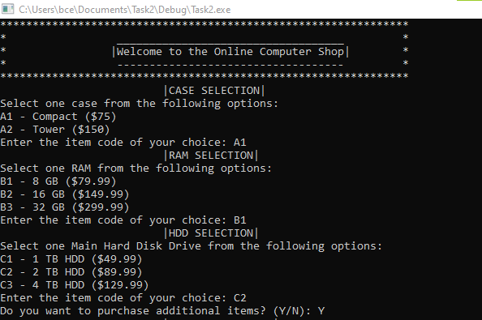

**This is the output that asks if the user wants to add more items then type Y otherwise N.**

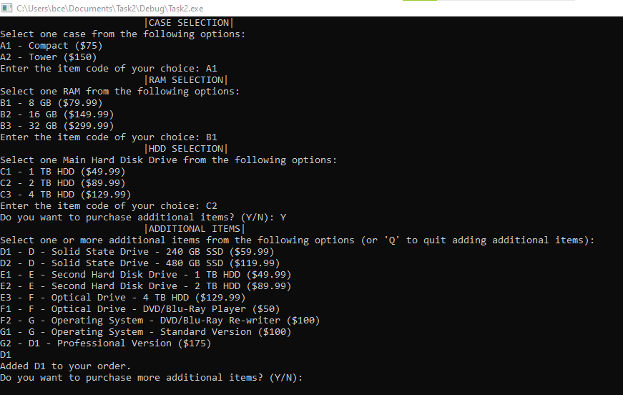

**After adding, if users want to add more then they can add.**

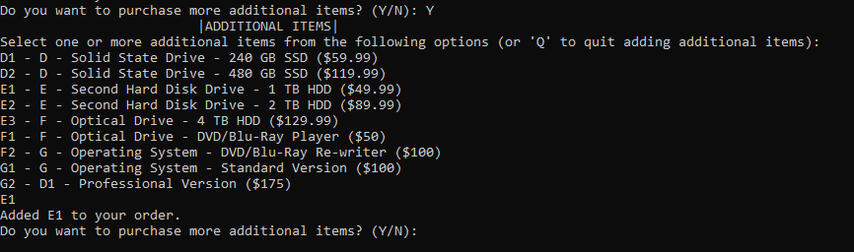

**By adding all items, the final item list and final price is shown:**

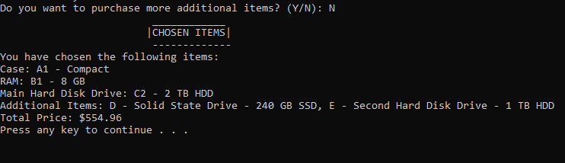

**If user enter wrong value then shows Errors.**

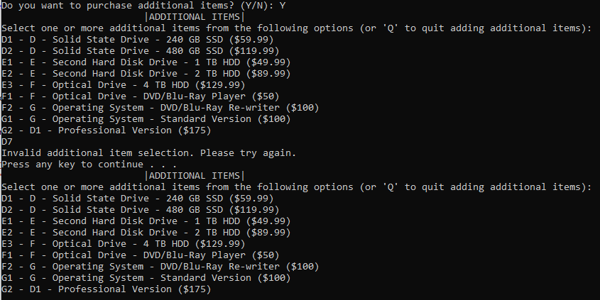

**Task 3**

**“Offering discounts”**

**Code:**

// Task3.cpp : Defines the entry point for the console application.

//

#include "stdafx.h"

#include <iostream>

#include <string>

#include <vector>

using namespace std;

const string caseItems[] = {"A1", "A2"};

const string caseDescriptions[] = {"Compact", "Tower"};

const double casePrices[] = {75.00, 150.00};

const string ramItems[] = {"B1", "B2", "B3"};

const string ramDescriptions[] = {"8 GB", "16 GB", "32 GB"};

const double ramPrices[] = {79.99, 149.99, 299.99};

const string hddItems[] = {"C1", "C2", "C3"};

const string hddDescriptions[] = {"1 TB HDD", "2 TB HDD", "4 TB HDD"};

const double hddPrices[] = {49.99, 89.99, 129.99};

const string additionalCategories[] = {"D - Solid State Drive", "E - Second Hard Disk Drive", "F - Optical Drive", "G - Operating System"};

const string additionalItems[][2] = {

{"D1", "240 GB SSD"},

{"D2", "480 GB SSD"},

{"E1", "1 TB HDD"},

{"E2", "2 TB HDD"},

{"E3", "4 TB HDD"},

{"F1", "DVD/Blu-Ray Player"},

{"F2", "DVD/Blu-Ray Re-writer"},

{"G1", "Standard Version"},

{"G2", "Professional Version"}

};

const double additionalPrices[] = {59.99, 119.99, 49.99, 89.99, 129.99, 50.00, 100.00, 100.00, 175.00};

void displayItems(const string items[], const string descriptions[], const double prices[], int size)

{

for (int i = 0; i < size; i++)

{

cout << items[i] << " - " << descriptions[i] << " ($" << prices[i] << ")" << endl;

}

}

double getPriceByCode(const string code, const string items[], const double prices[], int size)

{

for (int i = 0; i < size; i++)

{

if (code == items[i])

{

return prices[i];

}

}

return 0.0;

}

int main()

{

cout << "***************************************************************************" << endl;

cout << "* ___________________________________ *" << endl;

cout << "* |Welcome to the Online Computer Shop| *" << endl;

cout << "* ----------------------------------- *" << endl;

cout << "***************************************************************************" << endl;

string EnterCase, EnterRam, EnterHDD;

double totalPrice = 200.00;

vector<string> additionalItemCodes;

vector<double> additionalItemPrices;

// Choose a case

while (true)

{

cout << " |CASE SELECTION| " << endl;

cout << "Select one case from the following options:" << endl;

displayItems(caseItems, caseDescriptions, casePrices, 2);

cout << "Enter the item code of your choice: ";

cin >> EnterCase;

double casePrice = getPriceByCode(EnterCase, caseItems, casePrices, 2);

if (casePrice > 0)

{

totalPrice += casePrice;

break;

}

cout << "Invalid case selection. Please try again." << endl;

system("pause");

}

// Choose RAM

while (true)

{

cout << " |RAM SELECTION| " << endl;

cout << "Select one RAM from the following options:" << endl;

displayItems(ramItems, ramDescriptions, ramPrices, 3);

cout << "Enter the item code of your choice: ";

cin >> EnterRam;

double ramPrice = getPriceByCode(EnterRam, ramItems, ramPrices, 3);

if (ramPrice > 0)

{

totalPrice += ramPrice;

break;

}

cout << "Invalid RAM selection. Please try again." << endl;

system("pause");

}

// Choose Main Hard Disk Drive

while (true)

{

cout << " |HDD SELECTION| " << endl;

cout << "Select one Main Hard Disk Drive from the following options:" << endl;

displayItems(hddItems, hddDescriptions, hddPrices, 3);

cout << "Enter the item code of your choice: ";

cin >> EnterHDD;

double hddPrice = getPriceByCode(EnterHDD, hddItems, hddPrices, 3);

if (hddPrice > 0)

{

totalPrice += hddPrice;

break;

}

cout << "Invalid Main Hard Disk Drive selection. Please try again." << endl;

system("pause");

}

// Additional item selection

cout<<"***************************************************************************" << endl;

cout<<"* If you choose one additional item, You will get 5% Discount *"<<endl;

cout<<"* If you choose two or more additional item, You will get 10% Discount *"<<endl;

cout<<"***************************************************************************"<< endl;

cout << "Do you want to purchase additional items? (Y/N): ";

string additionalChoice;

cin >> additionalChoice;

while (additionalChoice == "Y" || additionalChoice == "y")

{

cout << " |ADDITIONAL ITEMS| " << endl;

cout << "Select one or more additional items from the following options (or 'Q' to quit adding additional items):" << endl;

// Display additional categories and items

for (int i = 0; i < sizeof(additionalItems) / sizeof(additionalItems[0]); i++)

{

cout << additionalItems[i][0] << " - " << additionalCategories[i / 2] << " - " << additionalItems[i][1] << " ($" << additionalPrices[i] << ")" << endl;

}

string addItemCode;

cin >> addItemCode;

if (addItemCode == "Q" || addItemCode == "q")

{

break;

}

bool validAdditionalItem = false;

double additionalPrice = 0.0;

for (int i = 0; i < sizeof(additionalItems) / sizeof(additionalItems[0]); i++)

{

if (addItemCode == additionalItems[i][0])

{

validAdditionalItem = true;

additionalPrice = additionalPrices[i];

break;

}

}

if (validAdditionalItem)

{

additionalItemCodes.push_back(addItemCode);

additionalItemPrices.push_back(additionalPrice);

totalPrice += additionalPrice;

cout << "Added " << addItemCode << " to your order." << endl;

cout << "Do you want to purchase more additional items? (Y/N): ";

cin >> additionalChoice;

}

else

{

cout << "Invalid additional item selection. Please try again." << endl;

system("pause");

}

}

// Calculate and apply discounts

double discount = 0.0;

if (additionalItemCodes.size() == 1)

{

discount = totalPrice * 0.05; // 5% discount for one additional item

}

else if (additionalItemCodes.size() >= 2)

{

discount = totalPrice * 0.10; // 10% discount for two or more additional items

}

double discountedPrice = totalPrice - discount;

// Output the chosen items, the amount saved, and the new price after the discount

cout << " ____________ " << endl;

cout << " |CHOSEN ITEMS| " << endl;

cout << " -------------" << endl;

cout << "You have chosen the following items:" << endl;

cout << "Case: " << EnterCase << " - " << caseDescriptions[EnterCase == "A1" ? 0 : 1] << endl;

cout << "RAM: " << EnterRam << " - " << ramDescriptions[EnterRam == "B1" ? 0 : (EnterRam == "B2" ? 1 : 2)] << endl;

cout << "Main Hard Disk Drive: " << EnterHDD << " - " << hddDescriptions[EnterHDD == "C1" ? 0 : (EnterHDD == "C2" ? 1 : 2)] << endl;

if (!additionalItemCodes.empty())

{

cout << "Additional Items: ";

for (size_t i = 0; i < additionalItemCodes.size(); i++)

{

for (int j = 0; j < sizeof(additionalItems) / sizeof(additionalItems[0]); j++)

{

if (additionalItemCodes[i] == additionalItems[j][0])

{

cout << additionalCategories[j / 2] << " - " << additionalItems[j][1];

break;

}

}

if (i < additionalItemCodes.size() - 1)

{

cout << ", ";

}

}

cout << endl;

}

cout << "Total Price: $" << totalPrice << endl;

cout << "Amount Saved: $" << discount << endl;

cout << "Discounted Price: $" << discountedPrice << endl;

system("pause");

return 0;

}

**Output:**

* If user choose just one additional item, he/she will get 5% Discount.
* If user choose two or more additional item, he/she will get 10% Discount.

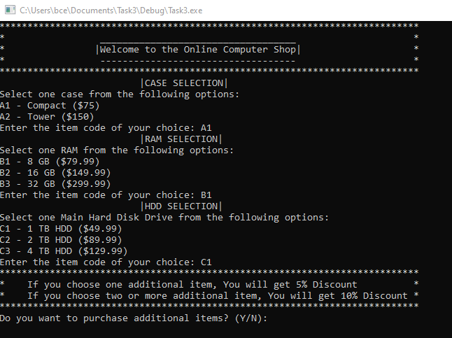

* By choosing one additional item, get **5%** discount.

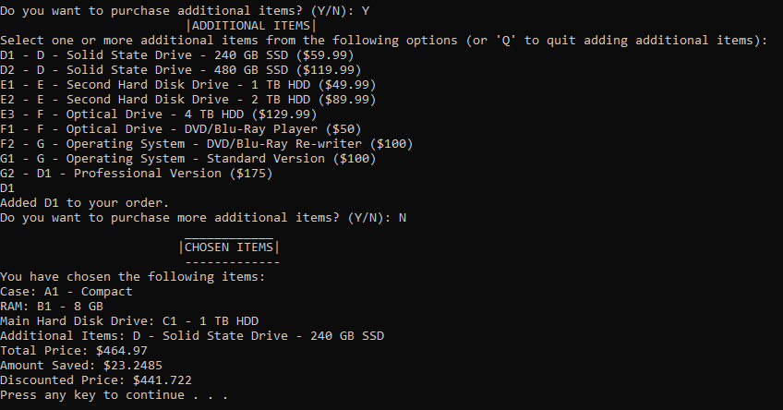

* By choosing two or more additional item, get **10%** discount.

